



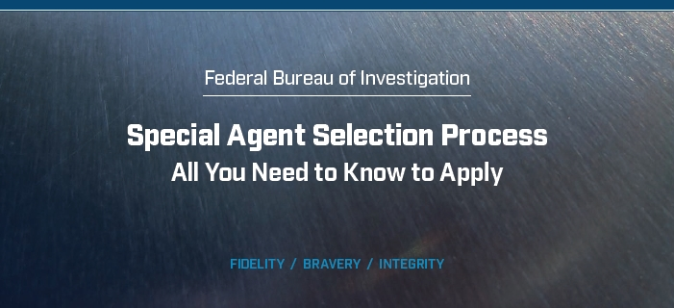

**Step 1: Application and Screening:**

You must attach to your application all other necessary forms (your official or unofficial transcripts, a DD-214 for

former members of the armed forces or your military enlistment contract for current members of the armed forces).

Applications are screened for eligibility and suitability.

Applicants who reside outside the United States should be aware that candidates must be available for travel

to the United States for testing. Travel is at the applicant’s expense. Candidates may choose whichever

Processing Field Office (PFO) is most convenient for them.

Timeframe: The initial screening process varies greatly and is dependent upon the completion of application

materials, the overall application volume and the current needs of the FBI. Following the guidelines in the Special Agent job posting and on FBIJobs.gov will expedite processing.

**Background Investigation Process:**

After you receive a conditional FBI offer of employment, you must complete the necessary documentation

to launch your background investigation. Once your background investigation is cleared, you will receive

your Top-Secret Clearance. You must be approved for a Top-Secret Clearance before beginning employment

with the FBI.

The investigation includes:

»» A polygraph examination.

»» Urinalysis test.

»» Fingerprints

»» Credit and records checks.

»» Extensive interviews with former and current colleagues, neighbors, friends, etc.

You will be contacted by the FBI Field Office processing your background investigation to schedule your interview,

urinalysis and polygraph examination.

The polygraph is used as an investigative tool to verify the truthfulness of your responses on the FBI background

investigation forms. In the next phase of the process, the FBI will perform extensive records checks (credit checks,

police records checks, etc.) and FBI investigators will interview past and present associates.

The background investigation process is very thorough; it can take several months or more to receive your

Top Secret Clearance.

**Things to Consider:**

Scheduling:

If you are currently employed, please be aware that you may be scheduled for testing during your regular working

hours (midday/midweek) and sometimes within a short timeframe.

If you are on active duty with the military, you must be within 15 months of completing your service before applying.

You may receive no more than a two-week notice to report to the Basic Field Training Course (BFTC) and must

successfully complete approximately 21 weeks of employment as a Special Agent trainee, while housed at the

FBI Academy in Quantico, VA.

Assignment Locations:

Flexibility is key at the FBI. You must be prepared and willing to be assigned according to the needs of the Bureau.

All Agents must sign and adhere to a mobility agreement, which states that as a Special Agent, you accept the

possibility of transfer as a condition of your employment. Once assigned to a Field Office, new Special Agents

are generally not transferred unless they request voluntary transfer, apply for management positions or as a result

of an emerging or existing critical need.

Upon graduation from the FBI Academy, you will be assigned to one of the FBI’s 56 Field Offices or satellite offices.

Roughly one-third of new Agents get their first choice. If you still aren’t sure about the transfer process, keep in

mind that the mission comes first. Over the past three years, on average, new Agents leaving Quantico have been

assigned to one of their top five-ranked offices. Furthermore, the FBI’s greatest need is in offices such as New York,

Los Angeles and San Francisco. If that’s where you want to be, we guarantee that’s where you’ll end up. San Juan

residents have a high possibility of returning to San Juan if that is your office of choice.

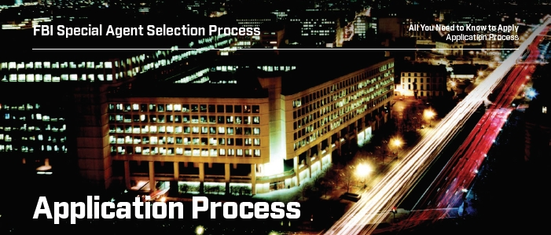

**Application and Required Documents:**

**DO:**

1. Fill out the Education, Work Experience and Profile

Information sections on the application. Include ALL

prior work experience.

2. Attach your resume and official or unofficial college

transcript(s) in the Attachments section.

* Current or former federal employees should also attach your SF-50.

3. Military veterans applying for veterans’ preference

should attach your DD-214 (Member 4 or Service

2 copy), Statement of Service (required if not yet

separated from the military), VA Letter dated within

one year and/or SF-15 (optional).

Note: When scanning and uploading document(s), make sure that all pages are readable and facing upright

in the same direction.

If you are missing any of the items listed above, please attach them to your profile as they become available and

notify your Applicant Coordinator upon completion. Your application will not be processed until you have provided

all the required documentation.

**DON’T:**

1. Attach a cover letter in the Attachments section.

Instead, fill out the Education, Work Experience

and Profile Information sections on the application.

2. Upload any picture files (JPEG, TIFF, PNG, BMP).

All uploaded documents to your application

should be in PDF format.

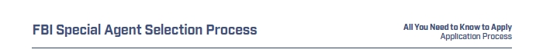**Minimum Qualifications:** The following minimum qualifications are required at the time of application:

»» Be a U.S. Citizen.

»» Be between 23 and 36 years of age.

»» Have a bachelor’s degree from a U.S.-accredited college or university.

»» Have at least two years of full-time professional work experience.

»» Have a valid driver’s license and six months of driving experience.

»» Meet the physical requirements.

»» Be able to obtain a Top-Secret Clearance.

**Technical Explanations and Exceptions:**

Age Requirement:

FBI Special Agents have a mandatory retirement age of 57. In order to achieve the required 20 years of service for

retirement, Special Agents must enter on duty no later than the day before their 37th birthday. Applicants must

apply for the Special Agent position prior to their 36th birthday to allow adequate time to complete the Special

Agent Selection System. *The FBI may disqualify applicants at any time during the process if it is determined that*

*they will reach age 37 before appointment.*

Potential Exceptions: Applicants with certain prior federal law enforcement service, applicants who are current FBI

employees or preference-eligible veterans may qualify for an age waiver.

»» **Non-Preference Eligible Candidates** — Applicants

with prior/current service as a federal law enforcement officer (LEO) and other federal positions (must be supported by an SF-50) do not require an age waiver if they will have amassed 20 years of service

by age 57.

»» **Current FBI Employees** — Special Agent candidates

who are current FBI employees must apply prior to their 39th birthday and be appointed to the FBI Academy no later than one day preceding their 40th birthday. They must successfully complete and pass all phases of the SASS and pass the background investigation to be considered for an age waiver.

»» **Preference-Eligible Candidates** — Applicants who

are members of the Armed Forces (rank 0-3 or below)

and are over the age of 36 at the time of application

may apply no sooner than 15 months prior to their

separation from the military. During initial processing,

the applicant will be required to submit a Statement

of Service from his/her Armed Services branch, with

an expected discharge/release date and Character of

Discharge (honorable or general). Preference-eligible

applicants must successfully complete all phases of the

Special Agent Selection System (SASS), pass the background investigation and submit a qualifying DD-214 before requesting an age waiver. Without a qualifying DD-214, an age waiver will not be considered.

Please Note: Veterans who retired at the rank of Major, Lieutenant Commander or higher (0-4 or higher), are not

eligible for preference in appointment unless they are disabled veterans. Applicants in this category must submit

a DD-214 at the time of application, along with the SF-15 and after appropriate/current Veterans Affairs disability

rating letter.

Education Requirement:

For ANY degree from an overseas institution, applicants must provide a foreign equivalency certification at the time

of application. No processing will take place without that documentation.

Potential exceptions: If a bachelor’s degree is not from a U.S.-accredited college, but your advanced degree

is from a U.S.-accredited college, the FBI will accept the accreditation of your advanced degree and no other

documentation is required.

Work Experience Requirement:

For Special Agents, professional work experience is defined as employment in:

»» Any occupation that requires a college degree

and may include specialized training.

»» Any position that includes managerial, supervisory

or leadership responsibilities.

»» Professional athletics such as a full-time career

participating in Major League sports (NFL, NBA, MLB,

NHL, etc.) or International Competitions (Olympics).

Summer jobs, internships, seasonal positions, temporary employment and/or volunteer work are generally

not considered in the professional work experience category.

In addition to the definition above, the FBI determines if an applicant meets the professional work experience

requirement based on the general requirements needed to perform Special Agent duties.

Potential Exceptions:

»» Applicants with a master’s and/or advanced degree(s) require one year of full-time work experience at the time of application.

»» For eligible veterans, part-time work, internships (paid or unpaid) and Reserve/Guard duty count toward total work experience. Volunteer work may be considered.

»» For all applicants, volunteer work (such as Peace

Corps) that requires full-time participation, paid fulltime graduate work programs and full-time fellowships may be considered as professional work experience. All exceptions will be made on a case-by-case basis.

**Core Competencies Evaluation:**

The FBI uses a category rating system and does not evaluate applicants against other applicants. You will be independently evaluated on the competencies listed below. Please ensure that these competencies are evident in your application and provide details on how each competency was demonstrated.

»» **Collaboration** — How did you Resolve and Manage Conflict, Demonstrate Political Savvy, Work with Others

and/or Liaise with an employee, co-worker, team or organization?

»» **Communication** — How did you Persuade, Listen and Interpret and/or Share Information with an employee,

co-worker, team or organization?

»» **Flexibility/Adaptability** — How did you Adapt and Manage Change by yourself, with an employee, co-worker,

team or organization?

»» **Initiative** — How were you Proactive, how did you Develop Yourself and/or how did you Serve the Public

by yourself, with an employee, co-worker, team or organization?

»» **Interpersonal** **Ability** — How did you Establish Rapport with others, Show Sensitivity to Differences,

Resolve and Manage Conflict and/or Work with Others to achieve common goals?

»» **Leadership** — How did you Mentor, Direct, Inspire and/or Set Strategic Direction for an employee, co-worker,

team or organization?

»» **Organizing** **and** **Planning** — How did you Plan, Prioritize and Follow Through by yourself, with an employee,

co-worker, team or organization?

»» **Problem** **Solving** **and** **Judgment** — How did you Identify Problems and Opportunities, Make Decisions, Manage

Risks and/or Evaluate and Analyze Problems/Situations by yourself, with an employee, co-worker, team or organization?

**How to Apply:**

The following instructions outline the FBI’s submission process. You must complete all sections of an application and submit any required documents by 11:59 PM Eastern Time on the closing date of the job posting/vacancy announcement.

1. Register for an account.
2. Search for a job posting on FBIJobs.gov.
3. Read the Terms and Agreements. If you agree, select the “I Agree to these terms” checkbox.
4. Select the “Next” button to begin your submission. Note: The number of sections in your submission will vary based on the job posting selected.
5. Complete all sections of your submission to include all questions in the Pre-Application Questionnaire Section. Note: Special Agent applicants must complete the Self-PFT and input their results in the application.
6. Based on the job posting, add required and optional document as attachments.
7. Review your completed submission and select the “Submit” button when ready to submit. Note: No changes can be made to submissions. If you wish to make changes, you will be required to withdraw and reapply.

If there is interest in your application, FBI HR specialists will initiate contact with you by email. If you have applied to a Talent Network, you will be asked to apply to the specific career track you have indicated. Note: Email from FBI will have a @fbi.gov extension. Please check you email spam filter to ensure receipt of these emails.

**How to Withdraw or Update an Application:**

In order to withdraw and application, navigate to the My Submissions section on the Careers page. Click the “Withdraw” button next to the application. Click the “Yes” button to confirm your selection. You will be prompted to select a reason and then click the “Submit” button. The status of the application will update to Withdrawn and the application will remain viewable.

Once an application is submitted, the resume and application information cannot be edited. To edit a submission, applicants must withdraw and reapply. To do so, applicants must follow the steps above. Once complete, reapply.

**Other Requirements:**

Males over the age of 18 are required to register with the Selective Service for all FBI positions; however, exceptions apply. If you meet one of the exceptions, please select “Yes” or “N/A” in the answer to this question on the application.

To request a reasonable accommodation on your application, please visit FBI.gov/accessibility and submit your request to the contact address provided.

**Document for Application:**

Before filing out your application, please take a movement to review the items below and ensure that you provide all the required documentation, if applicable.

Federal Resume Template:

An example is attached to the next few pages. Applicants should ensure their resume reflects this template and meets the guidelines outlined in the Federal Resume Guide.

SF-50:

Applicants with current or prior federal work experience should submit the SF-50 with their application.

DD-214:

Current or former members and veterans of the Armed Forces should fill out and include either the DD-214 or a Statement of Service letter with their application.